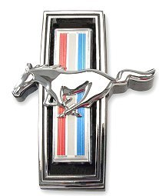 PONY TALES
AUGUST 2010 EDITION

CLUB OFFICERS

Frank Bayles—President—812-343-5093 or bayles@hughes.net
Kyle Weidner—Vice-President—724-272-3733 or kylew10@hotmail.com
Tammy Adams—Secretary—812-603-8207 or gohoosiers100@yahoo.com
Tieann Blackburn—Treasurer—812-347-1590 or claud.Blackburn@cummins.com

The Club will meet at the Golden Corral on Wednesday, August 11, 2010 at 6:00 PM for dinner and 7:00 PM for the meeting. Remember to mention that you are with The Club when you arrive to receive your 10% discount.



Cyndi Foley—August 2
Jim Rudicel—August 2
Terry Abel—August 6
Roberta Kirchoff—August 6
Marge Bott—August 8
Carletta Ault—August 12



^{Welcome to our new members!}
Richard A. Siefert

Treasurer's Report

We have a balance of $1268.61 in the bank.

*****The most recent photo album is missing from the 25th Club Reunion that was held in 2003 at Heflin Park. The photo albums were on display and Joan Mabe has reported that the most recent album is missing. If you attended this event back in 2003 and have any information please contact Joan Mabe at 812-376-8947*****

Club Outings

Mustang Night at Ritter’s—The Third Tuesday of every month now through October is Mustang Night at Ritter’s. The cruise-in starts at 6:00 PM each Tuesday night.

Road Rally—Saturday, August 14—Kyle and Steve Weidner are heading up this event. The Club will be leaving at 4:00 PM from Jay C Food Store located on Jonathan Moore Pike at Westhill Plaza. The Rally will last about 1 ½ hours and will end at Irwin Park in Edinburgh, Indiana. Hot dogs, hamburgers and table service will be provided. Please bring a covered dish and your own drinks. There will be a spark plug changing contest and other entertainment provided. You can attend the cookout without joining in on the rally. Please contact Kyle Weidner if you have any questions concerning the Rally. You can reach Kyle at 724-272-3733.

The Club History Committee will be meeting with a date and time yet to be determined. If anyone is interested in joining the committee, please let me know.

Somernites Cruise—Somerset, Kentucky—August 27-28th—Hotel rooms are available at the Holiday Inn Express for $90.00 plus tax. All the rooms have two queen beds. To place a reservation, please call the Holiday Inn Express at 606-425-4444 and request to be placed in the Hoosier Mustang Club block. Please call me at 812-603-8207 or email me at gohoosiers100@yahoo.com with any questions.

Club Car Show—MARK YOUR CALENDAR!! August 13, 2011 The Club will be hosting its first ever car show to be held in the parking lot of the Holiday Inn located on Jonathan Moore Pike in Columbus. Scott Barker will be serving as Chairman of the Car Show Committee, so let him know if you would be interested in volunteering. We are going to need everyone to make this show a success.

EVENT CORNER

Waymansville Car Show—September 11, 2010—see Bill Trimpe for more information.

Hope Cruise-In—held every Friday night in Hope, Indiana. There are baked goods available, corn-hole tournaments, music provided by the Hauser band and a dj.

MEETING MINUTES

- The Meeting was called to order and Frank welcomed everyone.
- The Treasurer’s Report was read. The current balance is $1268.61.
- Old Business—The Ice Cream Social was held at Hartsville on Saturday, July 10. Frank reported about the Corvette Car Show—there were 8 Club cars present. Ritter’s Cruise In on the 13th—5 Club members were present.
- New Business—Road Rally—August 14th beginning at 4:00 PM and ending at Irwin Park in Edinburgh, Indiana. Fall City Car Show will be held on July 16^{th.} Suds—several Club members are going to the Suds in Greenwood on Saturday the 17th. O’Reilly Auto Parts—Scott Barker reported on a new cruise-in location in Indianapolis on US Hwy 31 and Hanna. UMTR—Frank asked Scott Barker to provide a report on his racing. Scott is currently tied for first in points in his class. Mustang Night at Ritter’s—it was discussed that we would like to contact Ritter’s to find out what night we could have as Mustang night again since the last time we were rained out. Kyle Weider suggested that we propose the third Tuesday of every month. Frank will talk to Joe Draper about this. Claud Blackburn seconded the motion concerning this matter. Somerset Cruise in August—Frank reported that he will be leaving at noon on Friday to head to Somerset because there are some good spots available, if you get there early. All Street Shootout in Indianapolis was held July 9, 10, and 11—Scott reported that there were several serious cars there. O’Reilly Raceway Park—Frank wanted to know if they still allow street cars on the track. Tuesday night is for Street tire cars and Thursday is for Slick tire cars. Oktoberfest—Ed Byers is to look into contacts concerning the requirements for Parade participation.
- Frank closed the meeting and Steve Weidner seconded the motion.

***The Car Show Committee held its first meeting following the regular meeting. We have developed a tentative outline for this event***

 MEMBER SPOTLIGHT

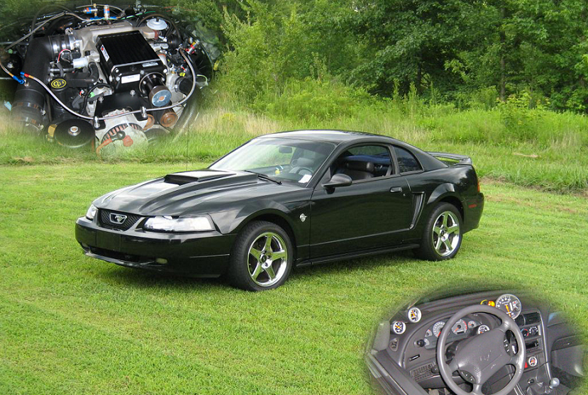

This month’s feature car is Russell Kuhn’s black 1999 Mustang GT. His car is black with black leather interior. The 4.6L engine is backed with a 5 speed transmission. In the six years he has owned the car, Russell has added a long list of modifications to the car including a Kenne Bell supercharger (11 PSI), NOS nitrous system, CNC ported cylinder heads, larger camshafts, long tube headers, off road “H” pipe, Magnaflow catback exhaust, Autometer gauges, Kaenen double cowl hood, MGW shifter, Pioneer Stereo, Kenwood amp & speakers, American Muscle ’03 cobra replica 10.5 inch rear wheels, 9 inch fronts. All of the work including most of the tuning, with the exception of painting the hood, was done by Russell. The car now spins the dyno rollers at 450 RWHP, not including the 50 HP shot of nitrous. Russell learned just before Christmas in 2004 that a modified Mustang is the worst car to have in the snow. He drove the car to work the last day before the Christmas shut down. Shortly after he goes to work it started snowing. By the time he could leave work there was a foot of snow on the ground. He lived in Madison at the time and the 40 mile drive took three hours to get home. He managed to keep the car on the road until he could not make it up a small hill in front of his house. He decided to park the car at a neighbor’s shop across the road where it did finally slide off into the ditch. At that point he gave up and walked home. It sat in the ditch for two days until his neighbor pulled it out of the ditch with his tractor and dragged it all the way to his house.

